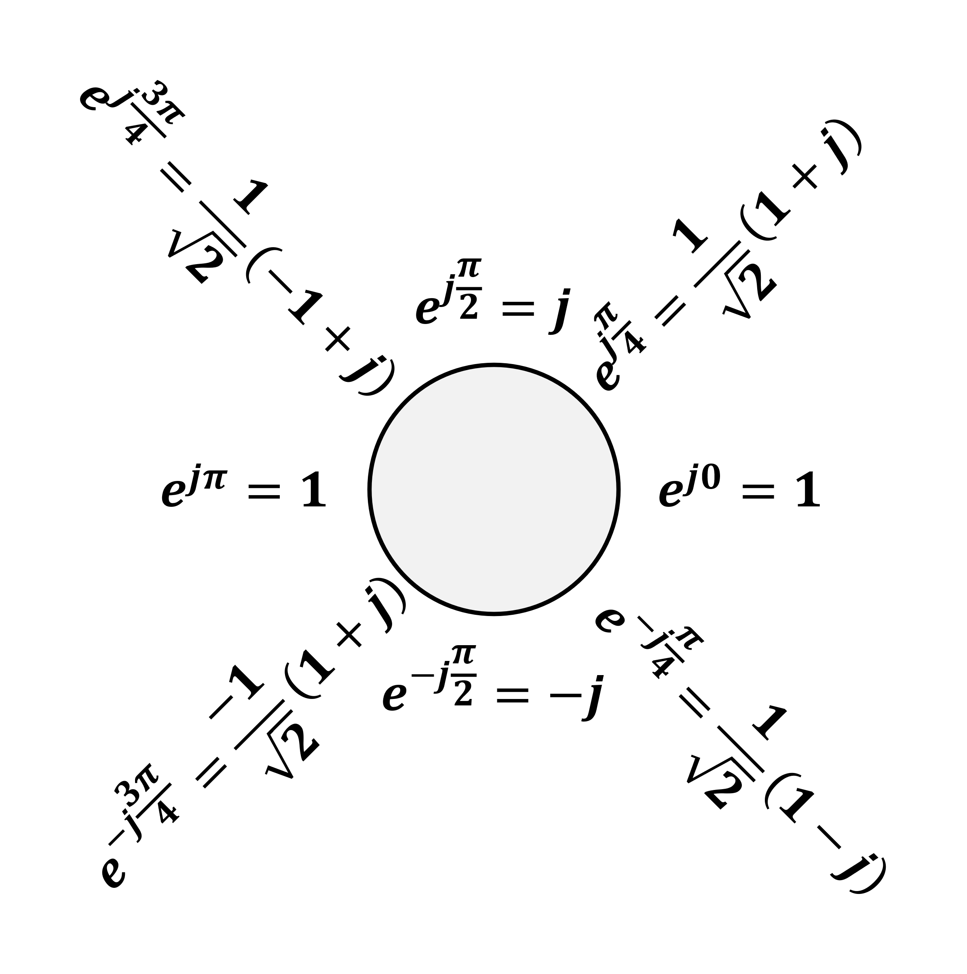

**System Properties (Z-Transform)**

|  |  |
| --- | --- |
| Causality | ROC is the exterior of a circle including infinity |
| Causality  (Rational $H\left(s\right)$) | ROC is the exterior of a circle outside the outermost pole + 分子z阶数不能比分母大 |
| Stability | ROC includes the unit circle |

Causal LTI system with rational $H\left(s\right)$: all poles lies inside the unit circle + 分子z阶数不能比分母大

**Nyquist Sampling Theorem**

Let $x\left(t\right)$ be a band-limited signal within $±ω_{M}$, then $x\left(t\right)$ is uniquely determined by its samples $x\left(nT\right)$ if $ω_{s}>2ω_{M}$, where $ω_{s}=\frac{2π}{T}$.

Nyquist rate: $2ω_{M}$

**诱导公式**

$\sin\left(2kπ+α\right)=\sin{α}$ $\cos\left(2kπ+α\right)=\cos{α}$ $\sin\left(-α\right)=-\sin{α}$ $\cos\left(-α\right)=\cos{α}$ $\sin\left(π-α\right)=\sin{α}$ $\cos\left(π-α\right)=-\cos{α}$ $\sin\left(π+α\right)=-\sin{α}$ $\cos\left(π+α\right)=-\cos{α}$ $\sin\left(\frac{π}{2}-α\right)=\cos{α}$ $\cos\left(\frac{π}{2}-α\right)=\sin{α}$ $\sin\left(\frac{π}{2}+α\right)=\cos{α}$ $\cos\left(\frac{π}{2}+α\right)=-\sin{α}$ $\operatorname{tg}\left(kπ+α\right)=\operatorname{tg}{α}$ $\operatorname{tg}\left(-α\right)=-\operatorname{tg}{α}$ $\operatorname{tg}\left(π-α\right)=-\operatorname{tg}{α}$ $\operatorname{tg}\left(π+α\right)=\operatorname{tg}{α}$ $\operatorname{tg}\left(\frac{π}{2}-α\right)=\operatorname{ctg}{α}$ $\operatorname{tg}\left(\frac{π}{2}+α\right)=-\operatorname{ctg}{α}$

**Time-Domain Sampling时域采样**

$x_{a}\left(t\right)\underset{↔}{CTFT}X_{a}\left(jΩ\right), x\left(t\right)=x_{a}\left(t\right)p\left(t\right)\underset{↔}{CTFT}X\left(jΩ\right)=\frac{1}{T}\sum_{k=-∞}^{∞}{X_{a}\left(j\left(Ω-kΩ_{s}\right)\right)}$

$x\left[n\right]={\left.x\left(t\right)\right|}_{t=nT}\underset{↔}{F}X\left(e^{jω}\right)={\left.X\left(jΩ\right)\right|}_{Ω=\frac{ω}{T}}=\frac{1}{T}\sum_{k=-∞}^{∞}{X_{a}\left(j\frac{ω-2kπ}{T}\right)}$

采样后信号的频率响应幅值变为 $1/T$ 倍，因此恢复信号时要通过一个增益为 $T$ 的BPF，BPF的截止频率最好为 $\frac{ω_{s}}{2}$； $Ω$ 轴上的 $Ω_{s}$ 对应 $ω$ 轴上的 $2π$

连续离散公式：时域 $t=nT$，频域 $ω=ΩT$，任何地方 $f=1/T$

时域采样导致频域周期化： $F_{out}=F_{in}±kF_{s}, Ω_{out}=Ω_{in}±kΩ_{s}$

**DFT Geometric Symmetry**

Geometric symmetry: $x\left[n\right]=x\left[N-1-n\right], θ\left(ω\right)=-\frac{N-1}{2}ω+β$ (type1 odd, type2 even)

Geometric anti-symmetry: $x\left[n\right]=-\left[N-1-n\right], θ\left(ω\right)=-\frac{N-1}{2}ω+\frac{π}{2}+β$ (type3 odd, type4 even), 中心系数为0

**DFT Matrix Relation**

$x=D_{N}^{-1}X, X=D_{N}x$

$D_{N}=\left[\begin{matrix}W_{N}^{0} & W_{N}^{0} & W_{N}^{0} \\ W_{N}^{0} & W_{N}^{1} & W_{N}^{2} \\ W_{N}^{0} & W_{N}^{2} & W_{N}^{4}\end{matrix}\right], D_{N}^{-1}=\frac{1}{N}\left[\begin{matrix}W_{N}^{0} & W_{N}^{0} & W_{N}^{0} \\ W_{N}^{0} & W_{N}^{-1} & W_{N}^{-2} \\ W_{N}^{0} & W_{N}^{-2} & W_{N}^{-4}\end{matrix}\right], D_{4}=\left[\begin{matrix}1 & 1 & 1 & 1 \\ 1 & -j & -1 & j \\ 1 & -1 & 1 & -1 \\ 1 & j & -1 & -j\end{matrix}\right]$

**信号的分解**

|  |  |  |
| --- | --- | --- |
| 奇偶分解 | $$x_{ev}\left(t\right)=\frac{1}{2}\left(x\left(t\right)+x\left(-t\right)\right) \\ x_{od}\left(t\right)=\frac{1}{2}\left(x\left(t\right)-x\left(-t\right)\right)$$ | $$X_{ev}\left[k\right]=\frac{1}{2}\left(X\left[k\right]+X\left[{〈-k〉}_{N}\right]\right) \\ X_{od}\left[k\right]=\frac{1}{2}\left(X\left[k\right]-X\left[{〈-k〉}_{N}\right]\right)$$ |
| 实虚分解 | $$x_{re}\left(t\right)=\frac{1}{2}\left(x\left(t\right)+x^{*}\left(t\right)\right) \\ x_{im}\left(t\right)=\frac{1}{2j}\left(x\left(t\right)-x^{*}\left(t\right)\right)$$ | $$X_{re}\left[k\right]=\frac{1}{2}\left(X\left[k\right]+X^{*}\left[k\right]\right) \\ X_{im}\left[k\right]=\frac{1}{2}\left(X\left[k\right]-X^{*}\left[k\right]\right)$$ |
| 共轭对称分解 | $$x_{cs}\left(t\right)=\frac{1}{2}\left(x\left(t\right)+x^{*}\left(-t\right)\right) \\ x_{ca}\left(t\right)=\frac{1}{2}\left(x\left(t\right)-x^{*}\left(-t\right)\right)$$ | $$X_{cs}\left[k\right]=\frac{1}{2}\left(X\left[k\right]+X^{*}\left[{〈-k〉}_{N}\right]\right) \\ X_{ca}\left[k\right]=\frac{1}{2}\left(X\left[k\right]-X^{*}\left[{〈-k〉}_{N}\right]\right)$$ |

**Geometric Series等比数列**

通项公式： $a_{n}=a_{1}q^{n-1}$

两项关系： $a_{n}=a_{m}q^{n-m}$

求和公式： $S_{n}=a_{1}\frac{a-q^{n}}{1-q}=\frac{a_{1}-a_{n}q}{1-q}$

**带通采样**

$Ω_{H}=M\left(ΔΩ\right)⇒$

$Ω_{T}=2\left(ΔΩ\right)=\frac{2Ω_{H}}{M}$

恢复使用gain为 $T$ 的 $Ω_{L}≤\left|Ω\right|≤Ω_{H}$ 的BPF

|  |  |  |
| --- | --- | --- |
| **系统性质的判据** | 输入输出关系 | 单位冲激响应 |
| Memoryless | Output at $t=t_{0}$ depends only on the value of input at $t=t_{0}$ | $h\left(t\right)=0$ for $t≠0$ |
| Invertible | There exist an inverse system | $∃h_{1}\left[n\right] s.t. h\left[n\right]*h_{1}\left[n\right]=δ\left[n\right]$ |
| Causality | Output at this time only depends on values of the input at the present time and in the past | $h\left[n\right]=0$ for $n<0$ |
| Stability | BIBO |  |
| Time-invariance | Let $x_{1}\left(t\right)=x\left(t-t_{0}\right)$ Check $y_{1}\left(t\right)=?y\left(t-t_{0}\right)$ | Must satisfy |
| Linearity | Let $x_{1}\left(t\right), x_{2}\left(t\right), x_{3}\left(t\right)=x_{1}\left(t\right)+x_{2}\left(t\right)$ Check $y_{3}\left(t\right)=?ay_{1}\left(t\right)+by_{2}\left(t\right)$ | Must satisfy |

**圆周卷积算线性卷积**

1. 补0法：两序列都补到 $M+N-1$ 长，算圆周卷积即可
2. Overlap-add: 将 $x\left[n\right]$ 切段，每段与 $h\left[n\right]$ 用补0法算圆周卷积，最后相加时要有 $N-1$ 长度的overlap
3. Overlap-save: 相加时不重叠，而是切断时重叠 $N-1$ 长度；最前面补 $N-1$ 个0，相加时每段舍去前 $N-1$

**Z-变换对快速检查单**

|  |  |  |  |
| --- | --- | --- | --- |
| **Signal** | **Transform** | **ROC** | **Pole** |
|  |  |  |  |
|  |  |  |  |
|  |  |  |  |
|  |  |  |  |
|  |  |  |  |

**Fourier-Domain Sampling频域采样**

频域采 $N$ 个样（不关心 $x\left[n\right]$ 周期是不是 $N$），时域信号就以 $N$ 为周期

$$y\left[n\right]=\sum_{n=-∞}^{∞}{x[n+mN]}, 0≤n≤N-1$$

多画几个周期找规律！

**Circular Time-Shift/Reversal**

原：0 1 2 3 4

移：3 4 0 1 2

反：0 4 3 2 1

**Group Delay, Phase Delay**

Phase delay: $τ_{p}\left(ω_{0}\right)=-\frac{θ\left(ω_{0}\right)}{ω_{0}}$

Group delay: $τ_{g}\left(ω\right)=-\frac{dθ\left(ω\right)}{dω}$

$$y_{a}\left(t\right)=a\left(t-τ_{g}\left(Ω_{C}\right)\right)\cos{Ω_{C}\left(t-τ_{p}\left(Ω_{C}\right)\right)}$$

**离散三角信号的周期性**

$ωN=2kπ⇒N=\frac{2kπ}{ω}$

**Sinc Function**

$$\operatorname{sinc}{θ}=\frac{\sin{πθ}}{πθ}$$

**2 $N$-Point DFT using a single $N$-Point DFT**

$v[n]$ 长 $2N$, $g\left[n\right]=v\left[2n\right], h\left[n\right]=v\left[2n+1\right]$

则 $V\left[k\right]=G\left[{〈k〉}_{N}\right]+W_{2N}^{k}H\left[{〈k〉}_{N}\right]$

**Hilbert Transform**

$$\frac{1}{πt}\underset{↔}{F}-j·\operatorname{sign}{ω},\cos{ω_{0}t}\underset{→}{h\left(t\right)}\sin{ω_{0}t}$$

**Convolution卷积**

$$y\left[n\right]=\sum_{k=-∞}^{∞}{x\left[k\right]h\left[n-k\right]}=\sum_{k=-∞}^{∞}{x\left[n-k\right]h\left[k\right]} \\ y\left(t\right)=\int_{-∞}^{+∞}{x\left(τ\right)h\left(t-τ\right)dτ}\int_{-∞}^{+∞}{x\left(t-τ\right)h\left(τ\right)dτ}$$

一个函数的 $t$ 换成 $τ$，另一个函数的 $t$ 换成 $t-τ$；如果结果以原点为界，记得写成 $u\left[n\right]u\left(t\right)$ 的形式； $x\left(τ\right)$ 的图像正常， $h\left(t-τ\right)$ 的图像关于 $y$ 轴翻转后，原点为 $t$

**和差化积公式与积化和差公式**

$\sin{α}+\sin{β}=2\sin{\frac{α+β}{2}}\cos{\frac{α-β}{2}}$ $\sin{α}-\sin{β}=2\cos{\frac{α+β}{2}}\sin{\frac{α-β}{2}}$ $\cos{α}+\cos{β}=2\cos{\frac{α+β}{2}}\cos{\frac{α-β}{2}}$ $\cos{α}-\cos{β}=-2\sin{\frac{α+β}{2}}\sin{\frac{α-β}{2}}$ $\sin{α}\cos{β}=\frac{1}{2}\left[\sin\left(α+β\right)+\sin\left(α-β\right)\right]$ $\cos{α}\sin{β}=\frac{1}{2}\left[\sin\left(α+β\right)-\sin\left(α-β\right)\right]$ $\cos{α}\cos{β}=\frac{1}{2}\left[\cos\left(α+β\right)+\cos\left(α-β\right)\right]$ $\sin{α}\sin{β}=-\frac{1}{2}\left[\cos\left(α+β\right)-\cos\left(α-β\right)\right]$

**Z变换特殊峰的判断**

信号为正，零点有峰

信号为负，无穷有峰

**Euler’s formula欧拉公式**

$$e^{jθ}=\cos{θ}+j\sin{θ} \\ \cos{θ}=\frac{e^{jθ}+e^{-jθ}}{2} \\ \sin{θ}=\frac{e^{jθ}-e^{-jθ}}{2j}$$

**信号的范数、能量、功率**

${\left\|x\right\|}_{p}={\left(\sum_{n=-∞}^{∞}{{\left|x\left[n\right]\right|}^{p}}\right)}^{\frac{1}{p}}, {\left\|x\right\|}_{∞}={\left|x\right|}_{max}$

${\left\|X\right\|}_{p}={\left(\frac{1}{2π}\int_{-π}^{π}{{\left|X\left(e^{jω}\right)\right|}^{p}}\right)}^{\frac{1}{p}}, {\left\|X\right\|}_{∞}=\max\left|X\left(e^{jω}\right)\right|$

$MSE=\frac{1}{N}\sum_{i=0}^{N-1}{{\left(\left|y\left[n\right]-x\left[n\right]\right|\right)}^{2}=\frac{1}{N}{\left({\left\|y\left[n\right]-x\left[n\right]\right\|}_{2}\right)}^{2}}$

Total energy: $ϵ_{x}=\sum_{n=-∞}^{∞}{{\left|x\left[n\right]\right|}^{2}}$ (Energy signal: finite energy)

Average power: $P_{x}=\lim_{K→∞}{\frac{1}{2K+1}\sum_{k=-K}^{K}{{\left|x\left[n\right]\right|}^{2}}}$ (Power signal: finite power)

Passive system: $ϵ_{y}≤ϵ_{x}<∞$, lossless system: $ϵ_{y}=ϵ_{x}<∞$

**离散三角信号的周期性小结论**

1. 周期 $N$ 必须是整数
2. 角频率相差 $2kπ$ 的信号完全相同
3. 任何数列的最大频率为 $π$（folding frequency），且对称频率（$0.6π$ 和 $1.4π$）信号相同